THE QI (WIRELESS CHARGING) SYSTEM

SECTION 1: HANDLING THE POWER TANSMITTION

Size of each cell is 155 × 89 mm.

The best solution for a high power Qi IC is the **TS80003** from Semtech.

24V Input / 40W Output Power

* Variable output voltage (19V default, up to 24V capable)
* WPC1.2 compliant
* Foreign object detection function
* Supports various smartphones charging protocols (with the latest firmware)
* Supports up to 15W output power with WPC1.2 receivers

It comes with integrated firmware and allows updates via a specified GUI. It also alows control via GPIO and has Good refernce designs available.

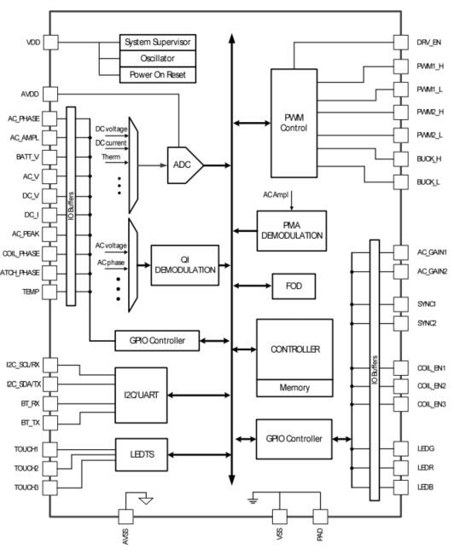

It can support up to 40W power transmission with multiple coil configuration or single coil configuration. Given our area to work with we might need multiple coils so that once a gadget is placed anywhere within the proximity it will still be able to charge with a specific coil.

-This will be achieved with a multiplexer.

- recommended coil is an 24uH A10 type coil at 19V (to be set with a resistor) to achieve the desired high-power output

- we ll need a H- bridge FET driver such as **TS61002** or its equivalent.

- A current sensor IC, switch and power mosfets with High Switching speeds (eg IPG20N04S4L, BSC0993ND)

- Power supply for the ICs.

SECTION 2: HANDLING THE AC TO DC POWER INPUT

System needs 24V input.

* Suggest a fly back transformer topology which is compact and provides high current capabilities depending on the design.(designing with the help of webench).